System Security: Lab Manual

MS Cyber Security

ITU Lahore



Submitted to: Muhammad Shehryar Raza

Submitted By: Eisha Nawaz

Roll No: MSCS22007

Lab 13: Kubernetes RBAC & Secrets Hardening
Mode: Group-based (Cluster Admin / Attacker / Auditor)
Tools:
- Kubernetes (Minikube or Kind)
- kubectl
- YAML editor

1. Learning Objectives
Students will:
- Understand Kubernetes RBAC concepts
- Identify overly permissive roles
- Harden access to Secrets
- Apply least-privilege principles in cloud-native systems

2. Scenario Description
A Kubernetes Pod has been granted a ClusterRole with access to all Secrets in the cluster.
Your task is to identify the misconfiguration and refactor RBAC policies so the Pod can only access one specific Secret.

3. Group Roles
- Cluster Admin: Reviews RBAC
- Attacker: Attempts to access Secrets
- Auditor: Verifies permissions

4. Prerequisites (Install Tools on Kali Linux)

Update system

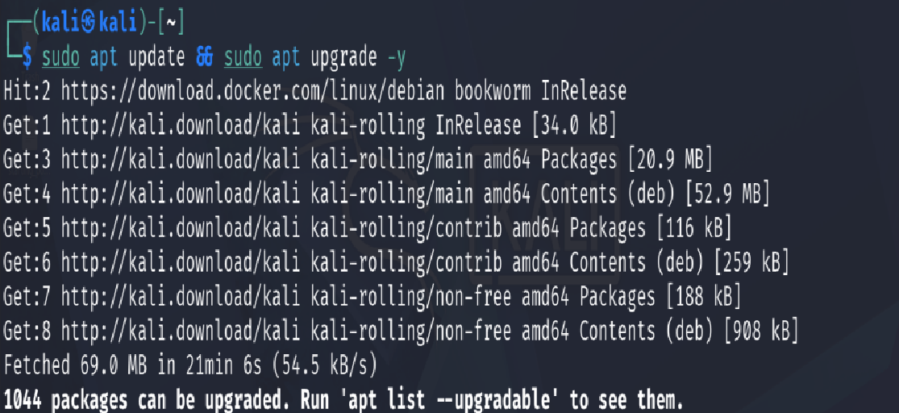Install kubectl
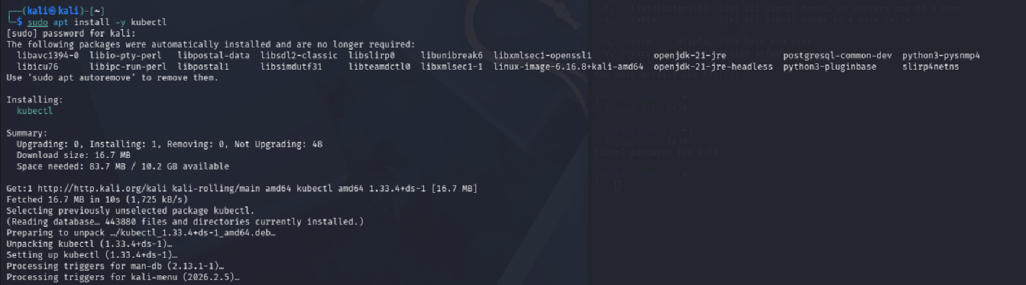

Install Minikube

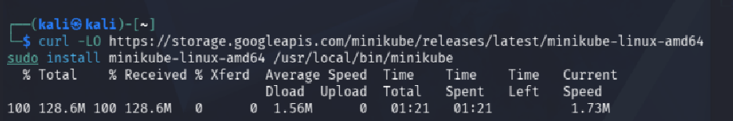Install Docker (Minikube driver)
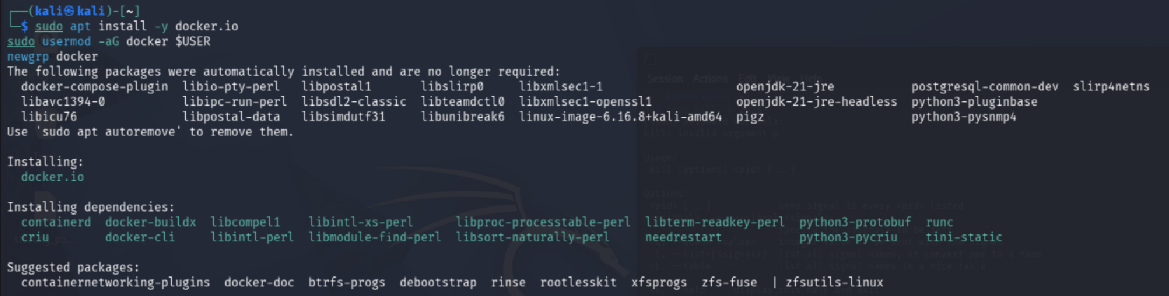

5. Environment Setup (15 minutes)

Start cluster:
minikube start
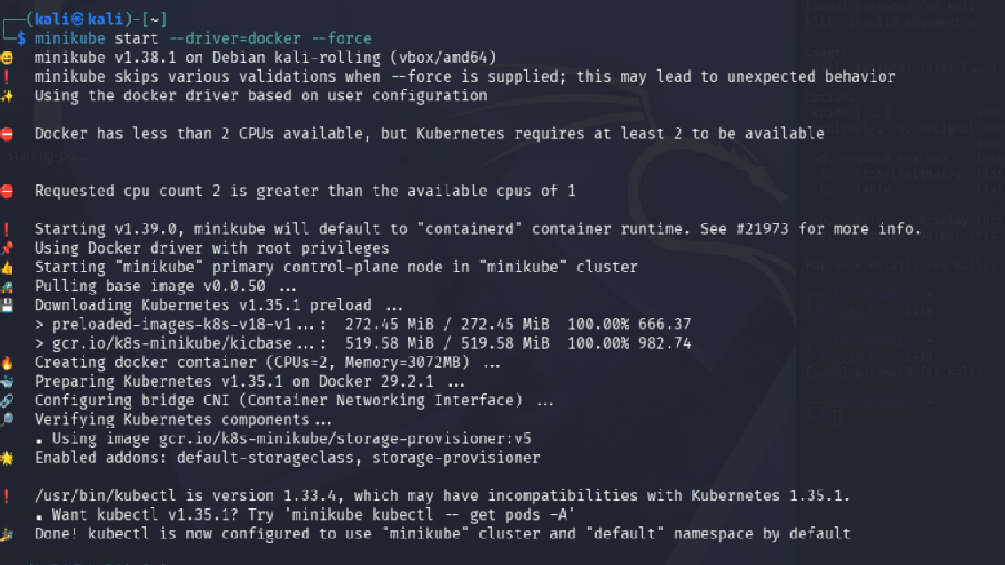

Create namespace:
kubectl create namespace insecure
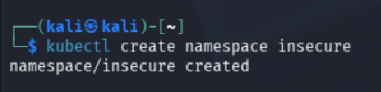
Deploy example app and secret (provided YAML).

Create the Secret (YAML)

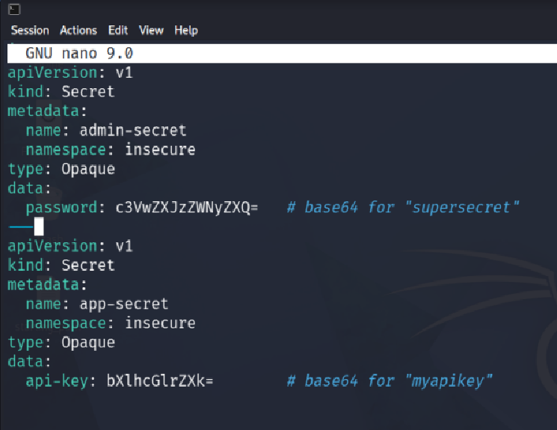
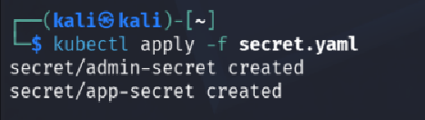

6. Step-by-Step Tasks

Task 1: Identify Over-Permissive RBAC

Create the Overly Permissive ClusterRole

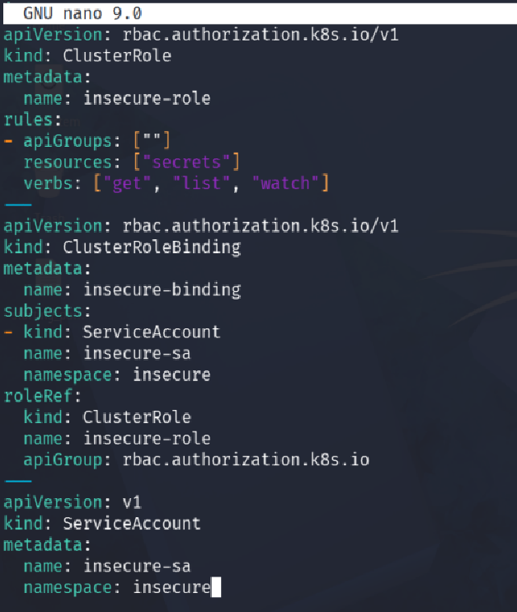
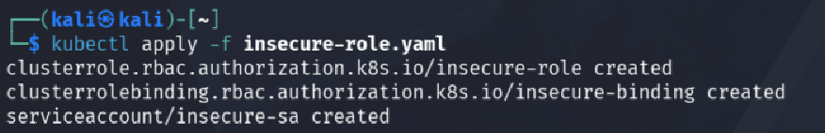

Inspect roles:
kubectl get clusterroles
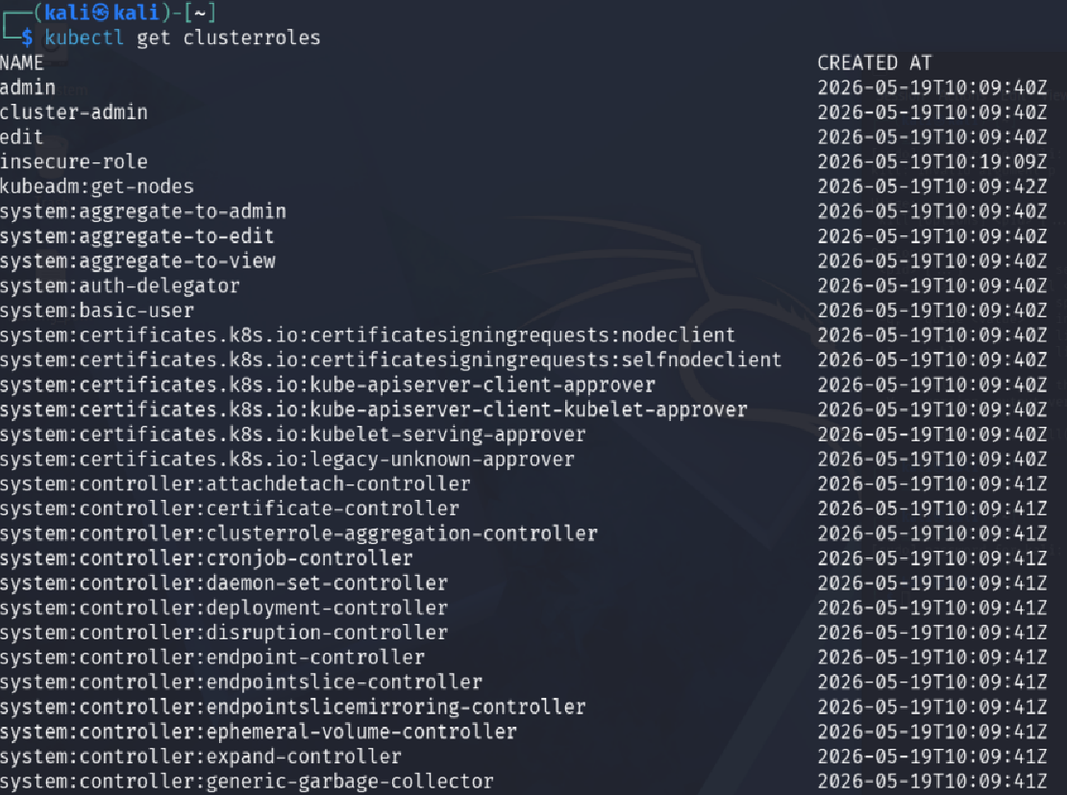
kubectl describe clusterrole insecure-role
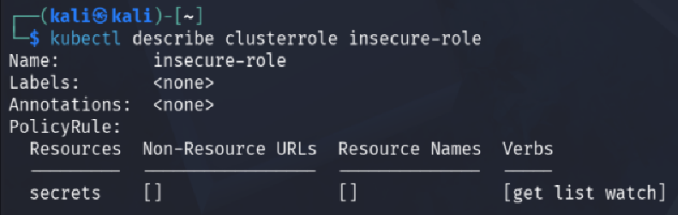

Observe:
- get, list, watch on secrets

Task 2: Exploit Excessive Permissions

From Pod:
kubectl get secrets -A
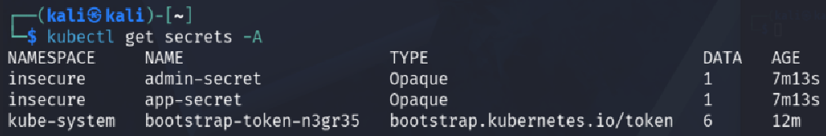
kubectl describe secret admin-secret
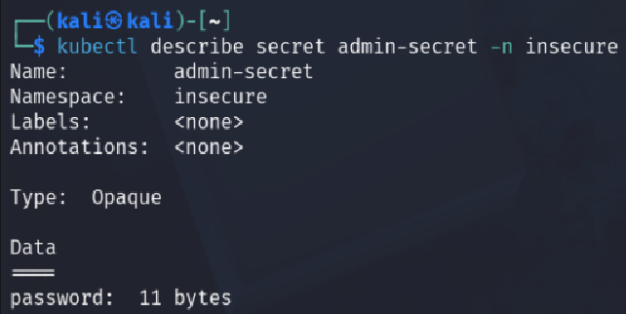
Confirm sensitive access.

Task 3: RBAC Refactoring

Delete the old insecure role
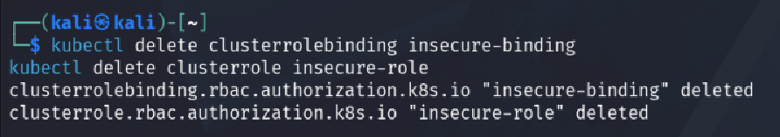

Create restricted Role:
rules:
- apiGroups: [""]
resources: ["secrets"]
resourceNames: ["app-secret"]
verbs: ["get"]
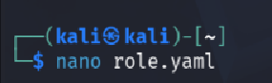
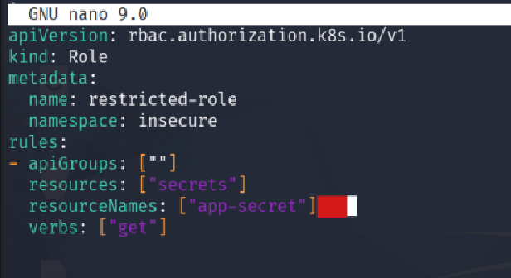

Create the RoleBinding
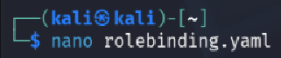
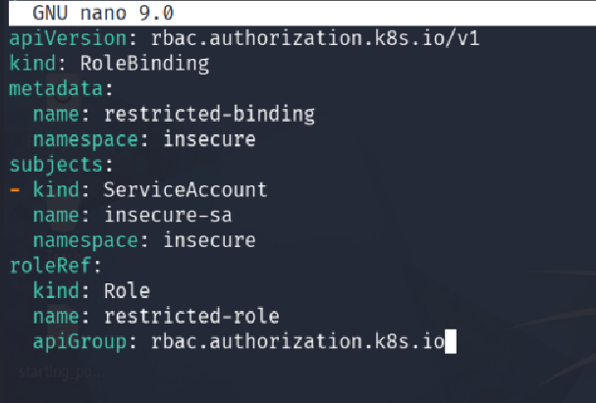

Bind role:
kubectl apply -f role.yaml
kubectl apply -f rolebinding.yaml
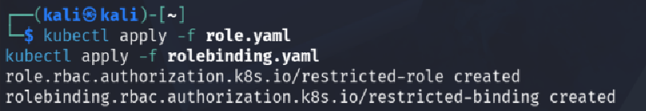

Task 4: Verify Least Privilege

Attempt:
kubectl get secrets -A

no cluster-wide access
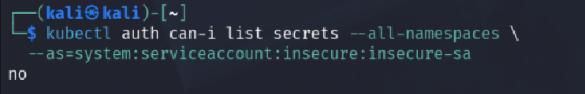

wrong secret
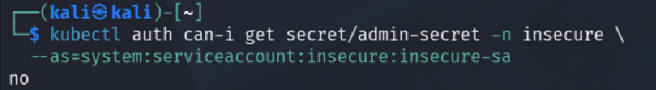

allowed secret only
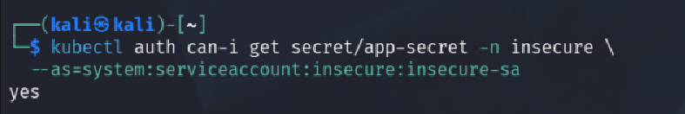
Access should fail except for allowed Secret.

Task 5: Reflection

Why Secrets are high-value targets
Because they hold credentials, API keys, TLS certs, the keys to the kingdom.

Why RBAC mistakes are common
Because Devs often over-provision permissions to "make things work".

Real cloud breach examples
Tesla (2018): exposed Kubernetes dashboard led to crypto mining via leaked AWS keys

Cleanup


